- Name : Ibrar Ahmed (Faculty)
- ID : 2k22F207
Department: CSE
Web Design Assessment - Hands on Tasks – 20th November, 2024 Test Duration: 1 Hr
Java Full Stack Afternoon Batch:
Q1. Write a JavaScript code to do the following tasks using given sample html page:-
- set paragraph background colour to yellow
- set font colour to green
- set font size to 25px
- Add a new paragraph dynamically in the same page with text “Javascript is also used as Client side scripting language.”
- Set new paragraph background colour to green
- Set new paragraph font colour to yellow
- Set new paragraph font size to 25px
- You can change the content of below page as required, note id for p tag, don’t change it.
- Add your script at the appropriate place/ section

<!DOCTYPE html>
<html>
<head>
<meta charset="utf-8" />
<title>JS DOM Paragraph Style</title>
</head>
<body>
<p id="para">
JavaScript is Server side scripting language for web development that enables dynamic and interactive user experiences.
</p>
<div>
<button id="jsstyle" onclick="js_style()">Style</button>
</div>

<script>
function js_style() {
// Target the original paragraph by its ID
const originalParagraph = document.getElementById('para');

// Set styles for the original paragraph
originalParagraph.style.backgroundColor = 'yellow';
originalParagraph.style.color = 'green';
originalParagraph.style.fontSize = '25px';

// Create a new paragraph dynamically
const newParagraph = document.createElement('p');
newParagraph.textContent = 'Javascript is also used as Client side scripting language.';

// Set styles for the new paragraph
newParagraph.style.backgroundColor = 'green';
newParagraph.style.color = 'yellow';
newParagraph.style.fontSize = '25px';

// Append the new paragraph to the body
document.body.appendChild(newParagraph);
}
</script>
</body>
</html>

OUTPUT 1 :
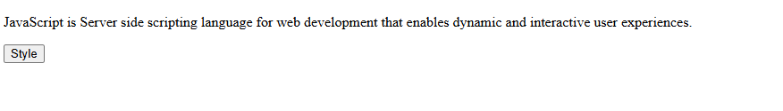
After clicking
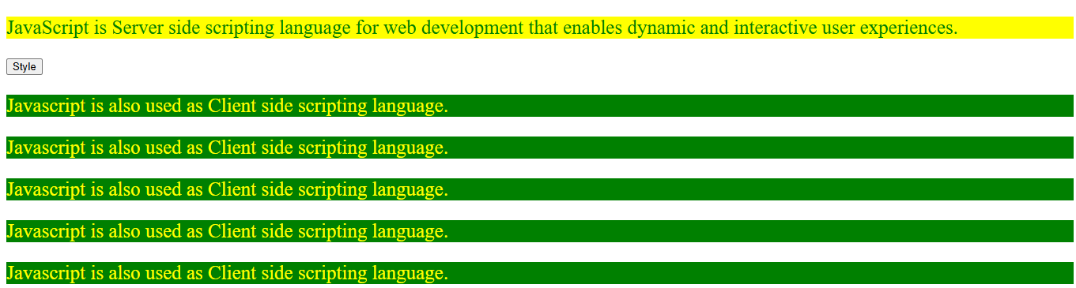

Q2. Design a web page that shows Product name, Brand name, Price and Quantity in a Table apply following styles.
- Set id of table to “product”.
- Set the background colour of table heading only to blue and font colour to white.
- Set the border of 3px to table
- Set padding 20px for all rows
- Center the table

Solution:
<!DOCTYPE html>
<html lang="en">
<head>
<meta charset="UTF-8">
<meta name="viewport" content="width=device-width, initial-scale=1.0">
<title>Product Table</title>
<style>
/* Center the table */
#product {
margin: 20px auto;
border: 3px solid black;
border-collapse: collapse;
}

/* Style the table headings */
#product th {
background-color: blue;
color: white;
padding: 20px;
}

/* Style table rows */
#product td {
padding: 20px;
text-align: center;
}

/* Ensure the table is responsive */
body {
font-family: Arial, sans-serif;
text-align: center;
}
</style>
</head>
<body>
<h1>Product Details</h1>
<!-- Table with specified styles -->
<table id="product">
<thead>
<tr>
<th>Product Name</th>
<th>Brand Name</th>
<th>Price</th>
<th>Quantity</th>
</tr>
</thead>
<tbody>
<tr>
<td>Smartphone</td>
<td>Samsung</td>
<td>$699</td>
<td>50</td>
</tr>
<tr>
<td>Laptop</td>
<td>HP</td>
<td>$999</td>
<td>20</td>
</tr>
<tr>
<td>Headphones</td>
<td>Bose</td>
<td>$199</td>
<td>30</td>
</tr>
<tr>
<td>Smartwatch</td>
<td>Apple</td>
<td>$399</td>
<td>15</td>
</tr>
</tbody>
</table>
</body>
</html>

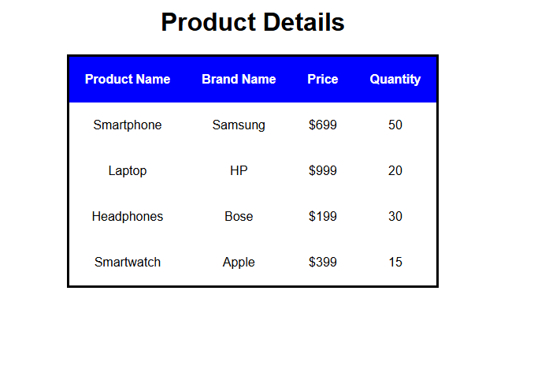
Output:

